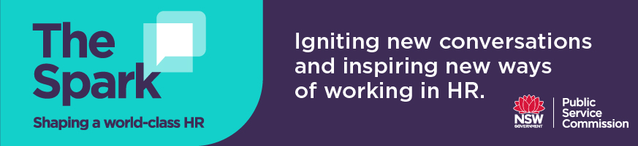
Discussion questions for Podcast 9
Jacqui Curtis

Changing role of HR: Future role of adaptive and flexible HR models leveraging technology, automation and responding to the ‘Volatile, Uncertain, Complex and Ambiguous’ (VUCA) world

- Transforming the HR function at the ATO began with understanding and building the capability of HR practitioners, seeking commitment from HR to develop the required capabilities and demonstrating the value of HR to the business. This approach enabled the HR function to develop the capabilities required to deliver outcomes for the business and involved being transparent about where HR is already delivering and adding value and where it needs to improve.

What capabilities does your HR team need to develop to better deliver business outcomes now and into the future? In what ways is your HR team already delivering for the business?

- Jacqui states that it is crucial for HR to not only have the right capabilities to deliver, but also to earn the trust and confidence from the business and have strong influencing skills. Two ways that HR can build credibility in their organisation and demonstrate their value are to:
- use evidence and data to build a business case
- use the language of the business and your understanding of the business (business acumen) to articulate the why and demonstrate impact
How have you/could you use evidence coupled with business acumen and using the language of the business, to demonstrate the value of one/more of your HR initiatives?
- Jacqui believes that one way to build the credibility of the HR profession and minimise the feeling of being undervalued amongst HR professionals is not only to have the courage to call people out when they refer to HR/Corporate functions as the “back office,” but to celebrate the success of HR in a public way and share what HR does and how we add value collectively.

How can you put your HR team in the spotlight and share the success stories of your HR team, either on a business level or emotional level in your organisation? Focus on being a good storyteller so your team’s contribution is heard.

- Jacqui mentions that the business doesn’t always know what it wants, and that HR needs to proactively come up with ideas to solve problems that are future-focused, strategic and take into account the workforce culture and what is happening in the broader environment or community. How can your HR team harness the changes in the business environment/community/workforce i.e. new ways of working and align this to the organisational strategy to guide leaders through disruptive change?

