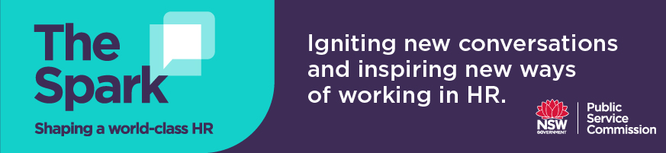
Discussion questions for Podcast 12
Margo Droulers

Changing role of HR: How to transition from transaction "policy police" to leading strategic and trusted business advisors

- Margo talks about the capabilities HR needs to effectively manage change:
- Generalist HR practitioners need good consulting skills to work in partnership with the business to understand and solve problems
- Specialist HR practitioners need to understand what their specialty is, and effectively translate this into day-to-day solutions

In your role as a generalist and/or specialist HR practitioner, how can you enhance your capabilities to manage change better?

- Design thinking is critical in our roles as trusted advisors and business partners, which involves understanding the problem from multiple users’ perspectives and experiences and building solutions together.

How do you/your team apply design thinking principles to your work?

- Margo believes in “earning the right to advance” and started to build trust in HR’s ability to add value at Macquarie University through firstly getting the basics right and transforming their recruitment practices and process issues.

How has your HR function demonstrated its ability to add value to the organisation? How can your team earn the trust of the business to better fulfill your role as trusted business advisors?

- How have you partnered with colleagues within your organisation to help solve problems, factoring in but not limited to compliance requirements?

- Margo applied a design thinking approach within the HR department to develop a HR strategy that focuses on getting basic process right, the desire to be trusted advisors, the capability development required and building strategic partnerships through a better understanding of the organisation as a whole.

Do you have a HR strategy in place in your agency? What key objectives would you like to see in your HR strategy? If yes, how could a design thinking approach be applied to ensure the strategy addresses key enablers to strategic outcomes and the capability needs in your team?

