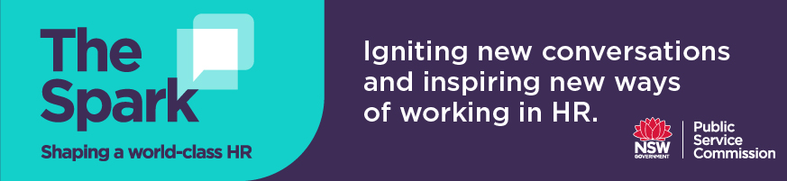

Discussion questions for Podcast 6
Richard Griffiths
Sourcing workplace and people insights – starting with the basics

- Is there a HR representative in your agency’s Executive team? Do you think this influences your HR team’s ability to shift away from primarily a transactional and reactive function to more of a business partner for the organisation?

- Why is it important to be adaptable and flexible to thrive in HR? What are some of the barriers that your team faces to working flexibly and being able to disrupt BAU to support innovation?

- How can you start to utilise your routine HR data/reporting to produce predictive analytics?

- Richard Griffiths talk about how at NSW Health they have used data to map out the patient experience and the employee experience to determine the relationships and impacts between them. This information provided the opportunity for preventative measures to be put in place to improve the patient experience. What kind of data can you extract and analyse in relation to the employee experience and customer experience in your agency? What relationships or impacts can be identified? Does this information allow you to prevent and/or improve customer/employee experiences?

- Richard refers to a list of capabilities that are required to set up a productive people analytics function, including data collecting, statistical analysis to generate insights, putting a people lens on the data and linking with business partners/other HR specialists, business acumen and information design/change management i.e. storytelling, data visualisation. Reflect on the current capabilities in your HR team/wider agency and what areas you require development and/or more resourcing.

- Understanding the business and what the business needs is crucial to building people analytics functions. How can you gain more insight and understanding of the needs of the business, to ensure people data and analytics supports business priorities?

