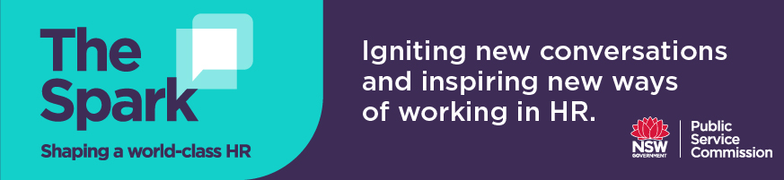

Discussion questions for Podcast 3
Natasha Fox and Ben Neal – Leading digital workforce transformation

- Natasha Fox discusses how the workforce has always been transforming, however today the pace of change has increased rapidly, and learning and relearning is required much faster than ever before. What challenges have you experienced when delivering HR services in a new/digital way, e.g. recruitment? How did you overcome them and what did you learn?

- Ben Neal observes that automating HR services for employees is often well behind the kind of digital services offered to customers and varies across NSW government agencies. Do you feel that the HR services provided to your employees matches the level of digital sophistication experienced by your agency’s customers? If so, has this had a positive impact on your staff’s experience and engagement with HR?

- The speakers offer the following tips for workforce planning:
- understanding that whatever enterprise decisions are made, they will have practical implications for the workforce and will need to be actively managed.
- importance of scenario planning cannot be under-estimated and how this helps in bridging and modelling out the workforce implications.
- the workforce plan absolutely must be implementable, grounded in practical and pragmatic actions, with near term actions for the next six months, 12 months and longer-term actions that need to be adaptable based on the scenarios you have modelled.

How do you ensure your workforce plan is practical and implementable?
- Do you agree with Ben that the “office is dead”, why/why not? What is your agency currently planning for returning to the office post Covid-19?

- What do you understand by the term ‘digital empathy’? Is your team building capability in this area as we continue to utilise digital environments to engage the workforce?

