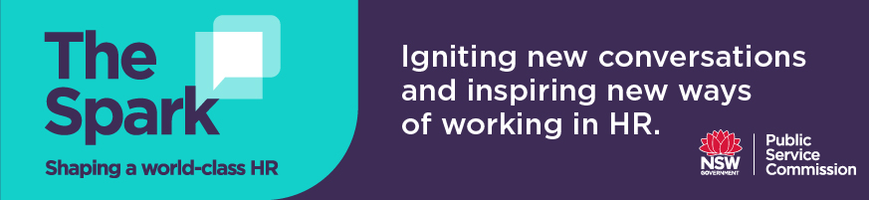
Discussion questions for Podcast 1 with Rhonda Brighton Hall – Talent management and the future of work

- What changes, if any, have you observed in how you/your team manages talent, performance and recruitment in the last 1-2 years?

- Rhonda posits that the most important questions HR should be asking themselves when thinking about talent management practices:
- Are our people developing?
- How many people are breaking through glass ceilings?
- Are people from diverse backgrounds getting to the top?
- How much time are you spending on supporting career development for people in your business group?

Is there where you spend your time in talent management?

- In Human Resources, we use ontologies all the time to arrange, document, and categorize lots of information about people (eg role descriptions, job families etc). A skills ontology helps organisations make sense of the skills and experiences needed now and into the future. Do you think they have a place in your workplace to support better recruitment practices, development and mobility opportunities?

- How do you/your team manage succession planning for critical roles in your agency? How many roles have you identified as “critical”, is it more of less than 25% of organisation roles? How often do you re-check if these roles are still critical?

- How does your organisation define potential?

- Culture

